Sunway UWB Keyless Entry GUI Documentation

By Michael He 6/28/2024

Language: C#

Engine: Unity Editor ver. 2022.3.29f1

How to use:

1. Launch UWBDemoGUI.exe
2. Attach UWB system to PC and check if port shows up on the top right of the GUI
3. Select a port and click “Open Port”
4. Once connected, turn on the key
5. After a small delay, the key should show up and be tracked by the UWB system
6. Modify threshold ranges and change camera by using the buttons on the right

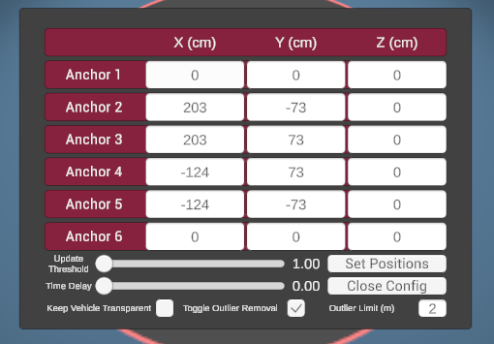

Anchor Config Settings:

1. Update Threshold
   1. Number of positions that the software will collect before calculating the average position vector and moving the GUI person (set to 3, means GUI will wait for 3 positions before calculating average position and moving the GUI person)
2. Time Delay
   1. Actual time delay in seconds (from 0 to 1 s) before the GUI will move the person; can be combined with UpdateThreshold to set a minimum number of positions to collect before movement. For example, if time delay is set to 0.1s and update threshold is set to 2, then the GUI will check after 0.1s has passed if there are 2 positions in the buffer; if so then the GUI will move the person
3. Keep Vehicle Transparent
   1. Constantly keeps the vehicle transparent so that user can see all anchors clearly, by default the vehicle is only transparent when the person is within the “inside” threshold
4. Toggle Outlier Removal
   1. Outlier removal will compare incoming position data with previous data and check if new position is outside of a range limit in meters; if it is outside that limit, that new position is disregarded as an outlier
5. Outlier Limit
   1. The range limit in meters that will be used for outlier removal

How to change anchor positions:

1. Click Open Anchor Config
2. Set anchor values for each anchor to the new anchor positions
3. Click “Set Positions”
4. If done successfully, there will be a message displayed that states that writing was successful.
   1. If there is no message or it says that writing was unsuccessful, then unplug and plug the USB cable and 12V power cable from the U2C module before repeating step 3
   2. Repeat until writing is successful
5. Click “Close Config”, the GUI should be updated to account for the new anchor positions

Debugging GUI Issues

* There is always a delay after turning on the key before the GUI receives data from the UWB
* If the key is turned on and on the right side there is no changes in the distances or key position, then the UWB system is not registering the key, see debugging the key section
* If the key is on and the right side is updating with key position, but there is no movement on the screen, most likely this means that outlier filtering has “lost” the keys position; This can happen randomly or because the key has moved too fast so the only position that UWB outputs is greater than the distance limit for outliers
  + open the anchor config panel, disable then reenable outlier filtering
  + if this is a constant issue due to fast movement of the key, then disable outlier filtering will rid this issue
* If after editing the anchor positions you cannot see every anchors anymore, this probably means that due to scaling sizes the anchors are within the car; you can either adjust the anchor positions on the vehicle to fit better or go into anchor config and toggle on “keep vehicle transparent” so that the car is see-through on the GUI

Debugging Key Issues

* If after turning on the key, nothing appears; check the following:
  + Try restarting first to see if that solves the issue
  + Make sure the port is connected and has not been disconnected
  + Make sure that the key is being powered on and its battery is secure; you can test to see if the key is powered by attaching it to the serial connecter for the key (without connecting it to the pc) and seeing If the light lights up
* If the key is still not showing up, do the following to factory reset the key:
  + Connect the key’s serial port of the key to the USB port of the PC by using the J-OB V2 USB to Serial converter module.

* + Install Coolterm and open it
  + Set baud rate to 115200 and connect to the port that the key’s serial connection is on

* + Type “factoryreset” into the terminal and press the “enter” key; the key should now work and show up on the GUI

* + Once finished the terminal will show Session ID 44332211 after the factory reset, as below. This indicates the key and the anchors are now connected.

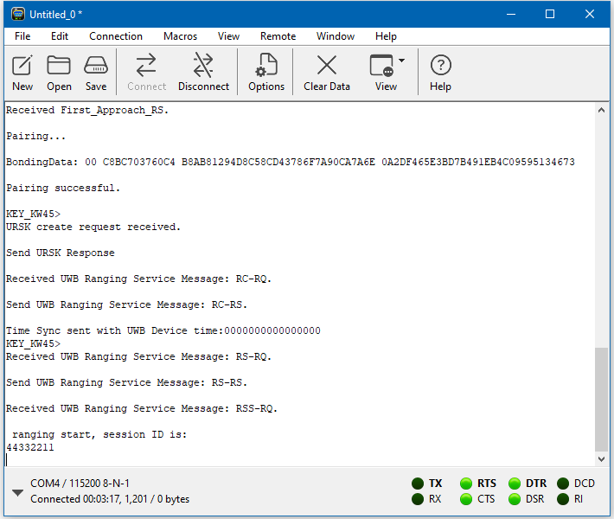

* + (Note, if when typing in Coolterm nothing shows up, this means the key is not connected; firmly connect the wires to the key and retry, you should be able to see what you are typing in Coolterm)
  + Disconnect the key once it is working
* If the key does not work when disconnected from the connector/pc, ensure it is powered and try factory resetting multiple times as needed
* If the GUI has any issues/odd behavior, please launch the debugging version of the GUI to diagnose issues

Editing Source Code

1. If new features need to be added or the source code needs to be modified to fix any unseen issue, the source code will need to be imported to Unity
2. Install the correct Unity Version (Unity Editor ver. 2022.3.29f1) and optionally install Visual Studios when prompted
3. Launch Unity Hub
4. Click on “Projects” then click “Add”
5. Select the source code folder
6. The projects page should now have UWBDemoCar, click to launch the editor

Editor Basics

* Unity works off using “objects” that you can see in the hierarchy on the left and “components” that are attached to the objects and are basically scripts. Each component can be seen on the right and can be modified
* The main objects to be modified will be “SerialPort” (contains CARSerialPortReader script) and “Person” (has “PersonPlaceholder” child object that contains the PersonMovement script)
* All UI additions/modifications are done as a child underneath Canvas, then underneath the respective “panel”; scripts will take values from the UI and modify UI values
* For editing scripts, they are all stored in the assets folder; script files use C# as well as some unity specific components, check the documentation for unity (<https://docs.unity3d.com/Manual/index.html>)
* Unity does not support multithreading well, instead coroutines (IEnumerator) are used to run code over the course of several frames while the main code is still running for any purpose where something must run over some duration; For example, reading from the serial port uses a coroutine since otherwise the program would constantly freeze and wait for data to be transmitted, by using a coroutine the data reading happens alongside the GUI without any interference

Important Source Code Files

* The application contains two important scripts and one debugging script:
  + CARSerialPortReader.cs – attached to “SerialPort” GameObject
    - Contains all code related to serial port communication, calculation of key position, movement + smoothening, outlier filtering, saving config, modifying scale of 3D environment, etc.
    - The “ReadSerial()” IEnumerator function is the function that handles reading data from the UWB system and verificatiotion
  + PersonMovement.cs – attached to “PersonPlaceholder” GameObject (underneath “Person” GameObject)
    - Contains all code that runs depending on position of the “Person” GameObject, such as making the threshold highlight green when inside and turning the “Person” to face the first anchor point
  + DebugConsoleScript.cs – attached to “DebugOBJ” GameObject
    - This a disabled script that causes all console log information to be printed on the screen, only enable when debugging is needed on a released build.